**Stock Market Prediction**

**Application User Guide**

**Version 1.1**

**Document version:**

|  |  |  |
| --- | --- | --- |
| **Date** | **Version** | **Remarks** |
| **27 Sep,2020** | **1.0** | **Application gives all closing and predicted price of last 60 days of chosen stock** |
| **12 Oct,2020** | **1.1** | **Predicts stock closing value of next day** |
|  |  |  |

**How to access the application of stock market prediction?**

1. The application is running on google cloud instance which has external IP to access it over the internet. I shall be keeping it down for cost effectiveness. So it will be accessible only when my device is up.

2. The IP is not elastic - each time it will be changed with reboot.

3. To access over internet:

http://<IP>:8501/

8501 is the port for the Streamlit application access.

4. This will be the interface :

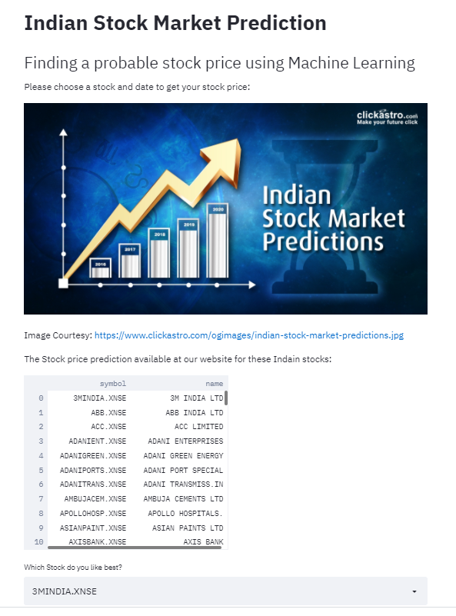

It shows you the available stock and their tickers.

5. Select the stock from the drop box.

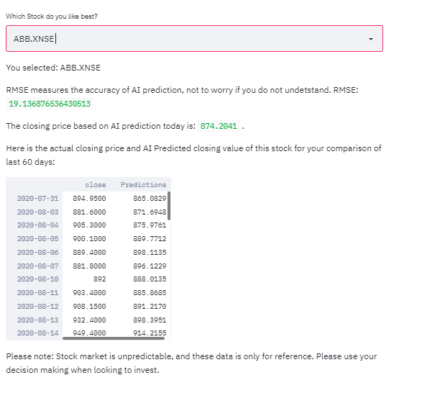

6. It shows the closing price and prediction for the particular stock for the last 60 days , also the next day closing price.

**Features to come:**

1.. The Prediction for the user chosen future date